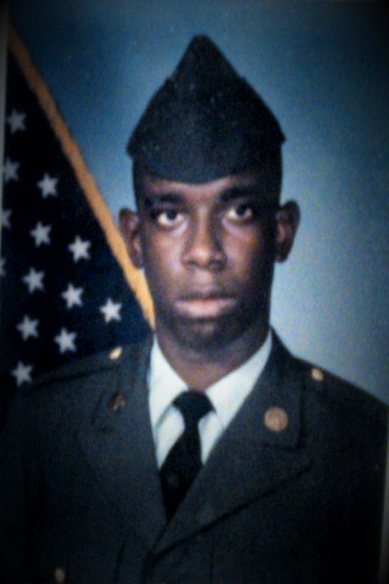
Ajamu (A J) A. Wazir
Ajamu attended Marshall High School, Marshall, Missouri. Was in both concert, and marching bands. Was a member of the JV, and varsity basketball teams. Listed in Who’s Who Among American High School Students. Was freshman class president. Enlisted in the US Army, graduated basic training in Fort Sill Oklahoma, Advanced individual training at Fort Bliss Texas, and did one overseas tour in South Korea. West Point tried to recruit him through his commanding officer. Attended Missouri Valley College in Marshall, Missouri. Majored in Human Service and Recreation, with a minor in world history. Managed Domino's Pizza in Lake Ozark, Missouri. Was assistant manager of Pasta House in Osage Beach, Missouri. Supervisor of internet sales at Kohl's department store in Lake Ozarks, Missouri. President of the T J W Family Charitable Foundation (TJWFCF) where he looks forward to helping people achieve their goals.

