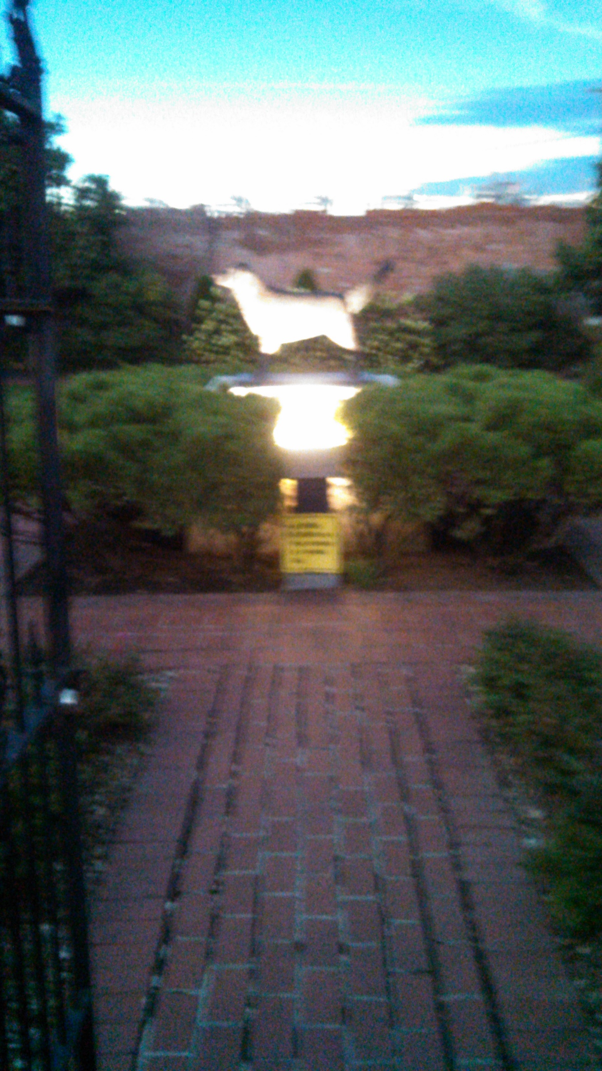

Jim The Wonder Dog, Moonstruck in Marshall, Missouri 1:15 P M, During the Total Solar Eclipse of 2017.
This picture of “Jim the Wonder Dog” – proclaimed The State of Missouri’s “Wonder Dog” by Governor Eric Greitens – is just our token of appreciation for your giving us consideration, and having read this far. Just in case you love animals and want to learn more about Jim the Wonder Dog go here: https://www.google.com/search?q=jim+the+wonder+dog&oq=jim+the+wonder+dog&aqs=chrome..69i57j0l5.8222j0j7&sourceid=chrome&ie=UTF-8
We, T J W Family Charitable Foundation, are just getting started as a grassroots people who have had enough of the way that things are going, so, we are reaching out to kindred spirits to make this world a better place. The Moon’s Shadow could be the start of a bright new day, for those of us who choose to make it that way.
The T J W Family Charitable Foundation’s website is https://www.tjwfamilycharitablefoundation.org .
Please feel free to send us any concerns that you feel people need to be doing to help one another to rise in this land of opportunity? Feel free to volunteer some time, where you are, to find out where the various places are that help the homeless, and or low-to middle income, and or stranded people so that we can put info together and make it available for their use as they move from place to place.
HELP US TO HELP OTHERS? DONATE WHAT YOUR HEART WILL ALLOW YOU TO, AS OFTEN AS YOU PLEASE. And THANK YOU!
Tadar, Founder: T J W Family Charitable Foundation

