T J W Family Charitable Foundation: HOMELESS HABITAT HOUSING
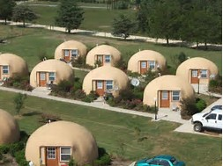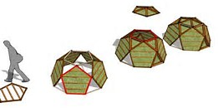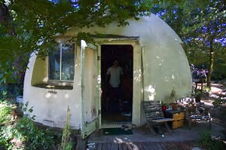
T J W Family Charitable Foundation is certified as a State of Missouri Not for Profit since 2016; its EIN: 81-4308488; it has a DUNS number, a SAM’s number, and is a 501(c)(3).

T J W Family Charitable Foundation collaborates with 501(c)(3) organizations, and is a member of the Pledge Donor Organization: https://pledgedonor.org/.

TJWFCF will address the needs of the vulnerable, poor, and homeless, using approaches of temporary housing for use for those who will be filing for permanent housing for renters where the people can rent or lease, or rent or lease to own.

TJWFCF will service military people’s and veteran’s homeless families, and those re-entering society from service, or incarceration in a program based on Habitat for Humanity concepts. They can help build their house with all the ownership items being only the cost of the needed goods and services to get them built without crippling interest added. TJWFCF will collaborate with funders like New American Funding to help these people to have bootstraps to pull.

For those who do an excellent job of building or rehabbing houses and want to go into business as a construction trade person by any name, TJWFCF will collaborate with them to get the best needed education, tools, and contracts for their first five years.

After that they must start making payments to repay TJWFCF to help TJWFCF to continue projected projects, or the collaborating loan donors the costs of their equipment, including a vehicle. If they quit, and are not in the red when they quit an independent audit will be made then they must start making payments two (2) months – sixty-one days – after they quit being a construction trade person by any name.

For that TJWFCF will need funding from others who are concerned about those who are willing to sacrifice all, so that we can enjoy what we have. The payments can go back to the funders or to TJWFCF to continue to help those in this situation. TJWFCF’s main concern is for the service people and veterans to not be worried about shelter, in this instance, – food and clothing will be addressed by a separate division of TJWFCF, or referred to other nonprofits – for self and or family.

