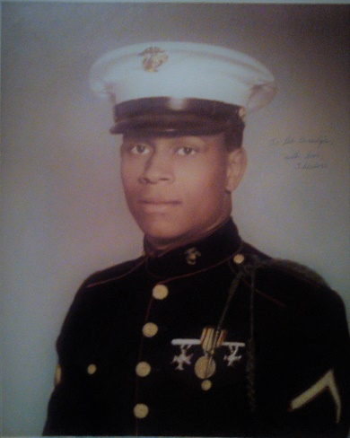

Tadar J. Wazir – Bio

Tadar J. Wazir is a born leader; and was destined to live his life in distinguished service for the betterment of all humanity. Tadar, from his earliest childhood development years, dreamed of being of service as a United States Marine. He embarked on a plan at the age of thirteen (13) years old that included running away from home to join, had he found opposition from family members who might oppose his plan. Tadar learned about an ROTC Training Program when he entered Central High School, in Kansas City, Missouri; he signed up, and spent three (3) years in complete dedication to everything Military, reading every book in the school’s library that had a military title or subject attached, and was a member of the school’s rifle team. Before graduation from high school, Tadar joined the United States Marines Corps via its 120 Day Delay Entry plan. Tadar made Marine Corps “Boot Camp” history in his assigned Platoon 244, as its Right Guide (Flag Carrier). Tadar served two (2) tours of duty in the Vietnam War beginning just before Christmas 1964 through February 1965; his unit was engaged in Special Ops with Navy Seals in Vietnam.

After his honorable discharge from military service, Tadar advanced himself academically acquiring degrees in Administration of Justice; and minored in Mobile Emergency Medical Technology, and consistently made the Dean's List in his academic accomplishments. Tadar, while taking courses at Arkansas A. M. & N. College, in Pine Bluff, Arkansas; cofounded its ROTC program.

Tadar J. Wazir is a man anchored in high morals, and spiritual intuition, and that intuition had him embark upon years of intense studies in: World Religions; The Bible; The Torah; The Qur’an. He has been taught and mentored by two (2) world renowned religious leaders, and he has reached the level in national acclaim as a Religious Scholar and Interfaith Leader. Tadar J. Wazir is listed in Who's Who Among Human Service Professionals; Who's Who in Religion; Who's Who in America; Who's Who in the Mid-West; Who's Who in Medicine and Health Care; and Men of Achievement in Cambridge, England. The BBC interviewed him live in 1993 at the Council for a Parliament of the World’s Religions, held in Chicago, Illinois. Tadar was a participant in that historic five (5) day “Council for a Parliament of the World’s Religions” celebrating its first-time reconvening in over 100 years, and only the second time in history wherein each and all the religions in the world came together in interfaith council. Tadar is a frequent guest on Radio, Television, and Cable Stations, and a go-to-source for Newspapers. Tadar is a frequent guest speaker at Colleges, Universities, Churches, and Synagogues. Additionally, Tadar is a Published Author and has written and published many treatises.
Tadar’s outstanding life of service and his knowledge of all religions qualified him for esteemed appointments as: Volunteer and Contract Chaplain with the United States Disciplinary Barracks (USDB) in Ft. Leavenworth, Kansas; the United States Penitentiary and its Camp in Leavenworth, KS; and The United States Medical Center for Federal Prisoners, in Springfield, Missouri. Tadar J. Wazir recently retired from his historic career as a Chaplain/Hostage Negotiator for the State of Missouri, Department of Corrections, Division of Human Services, and Tipton Correctional Center. Tadar was appointed by several City Councils of Marshall, Missouri as their liaison board member for the University of Missouri’s Outreach/Extension Service.

Tadar founded the T J W Family Charitable Foundation, and again has placed his sights on service to the millions of wounded, homeless, and too often forgotten service members (male and female) in need of a vast array of services. The work is great, and workers are few!

For additional information contact: Tadar J. Wazir: tjw@tjwfamilycharitablefoundation.org

