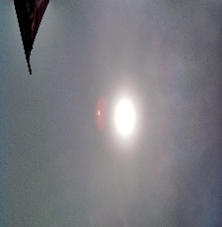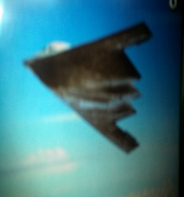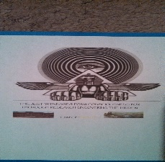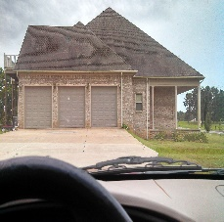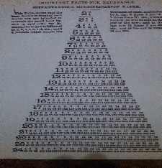
S T R E A M

ABOUT US

T J W Family Charitable Foundation is certified as a State of Missouri Not for Profit since 2016; its EIN: 81-4308488; it has a DUNS number, is SAM’s registered, and is a 501(c)(3).

The T J W Family Charitable Foundation, hereinafter TJWFCF, is just what it sounds like: a way for TJWFCF to be a good neighbor and give back to the communities we all call home.

The TJWFCF will be growing to encapsulate the STREAM aspect of humanitarian services:
S: science, T: technology, R: research/religion, E: engineering, A: arts, M: mathematics.

TJWFCF’s goal is to engage with the people around us, and provide support to organizations committed to neighborhood improvement. We focus on addressing education, holistic health care, poverty and homelessness, workforce development, gender equality, societal re-entry with emphasis given to active duty military personnel, veterans, and the families of both, and service animals.

The TJWFCF will address the needs of the vulnerable, poor, low-middle income, and or homeless.

Grant Inquiries

The TJWFCF accepts grant requests on a funds available basis from those who have been invited to apply for them. If you would like to qualify for a grant invitation, please email TJWFCF at tjwfcf@tjwfamilycharitablefoundation.org with your organization’s name and purpose, and contact information.

