T J W Family Charitable Foundation: INTERFAITH
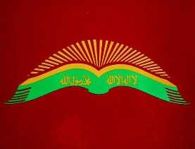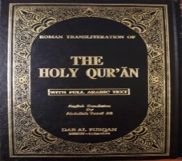
T J W Family Charitable Foundation is certified as a State of Missouri Not For Profit since 2016; its EIN: 81-4308488; it has a DUNS number, a SAM’s number, and is a 501(c)(3).

T J W Family Charitable Foundation collaborates with 501(c)(3) organizations, and is a member of the Pledge Donor Organization: https://pledgedonor.org/.
TJWFCF addresses the needs of one’s spirit.
TJWFCF will be using religious and spiritual approaches with emotional help for each person coming from that one’s specific faith’s Higher Power’s guiding light; and the United States Code of Federal Regulations, Title 38, as a guide for government help; along with any volunteers that will come in from their faith group to counsel, mentor, and instruct others via classes as to their beliefs, practices, and validity; interfaith sessions; and historical tours to educate people on America’s glorious history.
TJWFCF will have them apply their religious, and or spiritual concepts, and principles via Jr. Achievement like activities that should give them the mind-set of the civil and moral business people, who know that one must be concerned about others to truly be successful.

