Pictures of the Total Solar Eclipse of 2017 in Moonstruck Marshall, Missouri, on an overcast day around 1:15 p m.

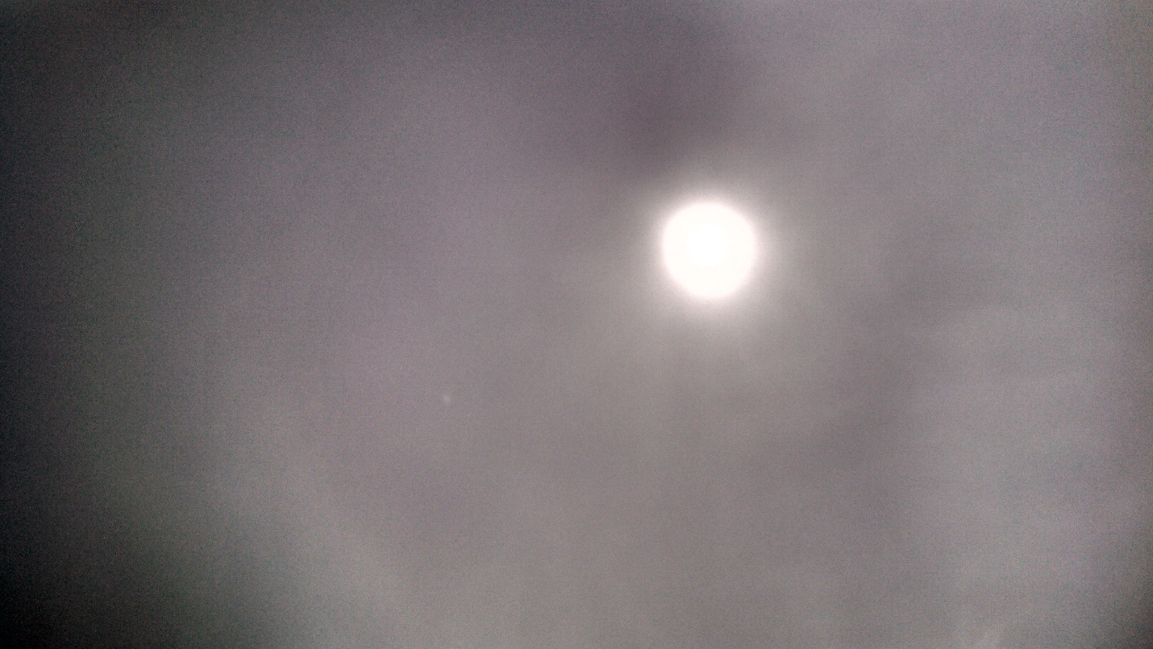
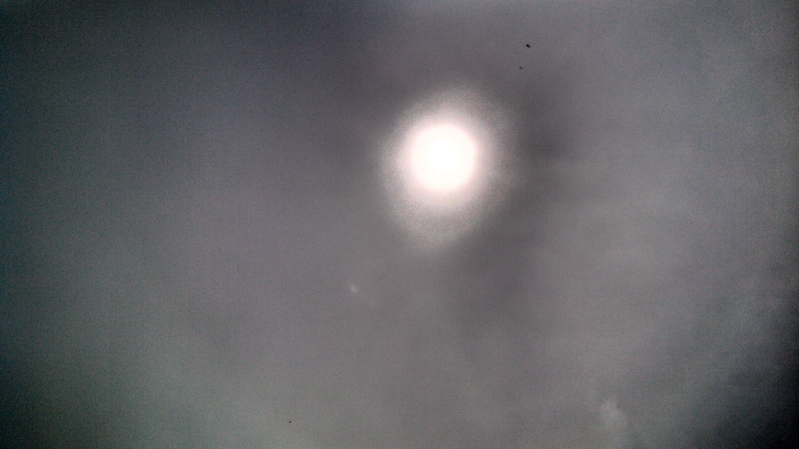
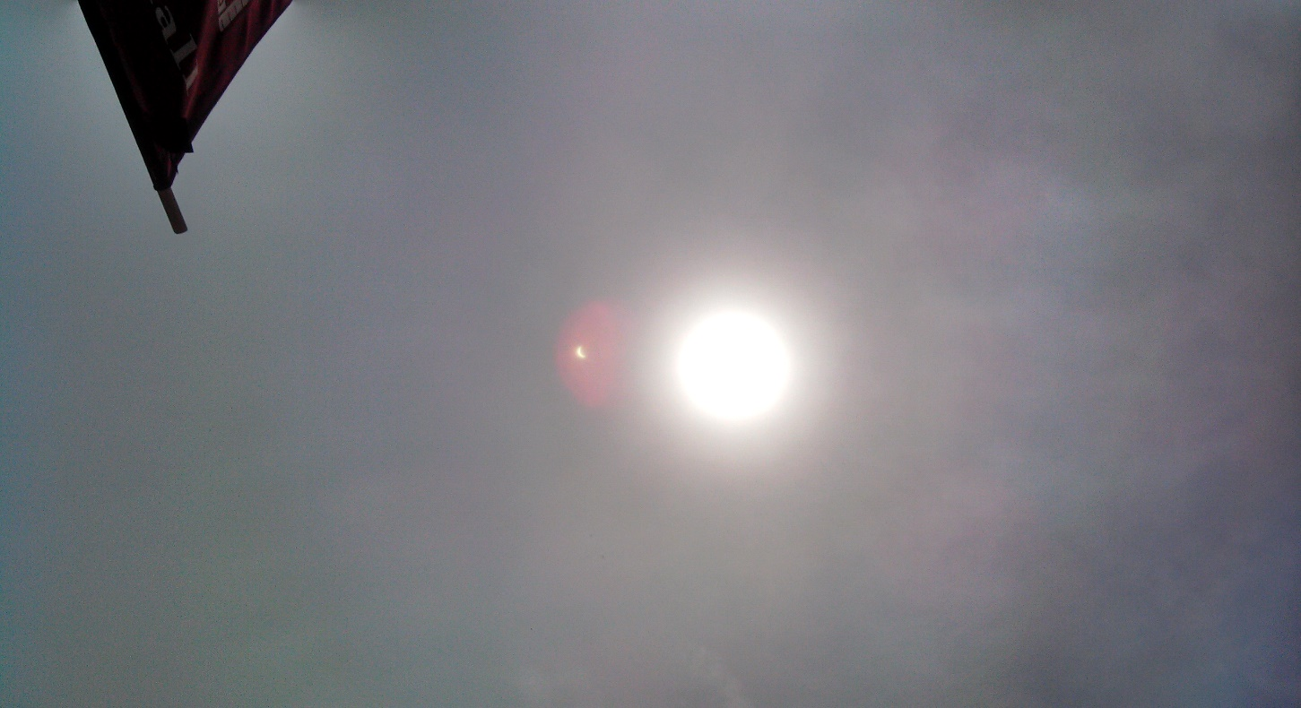

The T J W Family Charitable Foundation’s website is https://www.tjwfcf@tjwfamilycharitablefoundation.org we are a member of the Pledge Donor Organization: https://pledgedonor.org/.
These pictures are our token of appreciation for your thoughts of a donation to help us financially.
Please feel free to send us any concerns that you feel people need to be doing to help one another to rise in this land of opportunity? Feel free to volunteer some time, where you are, to find out where the various places are that help the homeless, and or low-to middle income, and or stranded people so that we can put info together and make it available for their use as they move from place to place.
We are just getting started, grassroots people who have had enough of the way that things are going, and reaching out to kindred spirits to make this world a better place. The Moon’s Shadow could be the start of a bright new day, for those who choose to make it that way.
These Total Solar Eclipse of 2017 pictures were taken with an uncovered cell phone. Question: What is that smaller object that is throwing off so much heat (red waves). We didn’t see it!
HELP US TO HELP OTHERS? DONATE WHAT YOUR HEART WILL ALLOW YOU TO, AS OFTEN AS YOU PLEASE. And THANK YOU!
Tadar, Founder: T J W Family Charitable Foundation

